1. Setup Docker

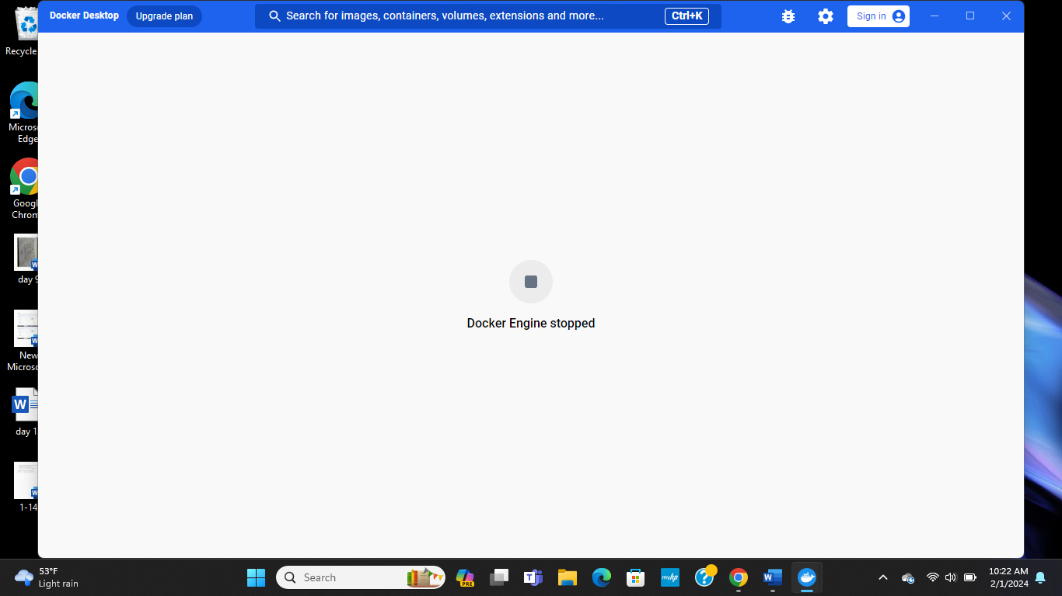

1. Setup IAM Role to copy folder using crontab from ec2 to s3

3) aws cli (aws s3 sync <source> <destination>

